Mushroom-Nut Cakes with Iceberg Salad

[Get this meal!](https://www.thepurplecarrot.com/users/sign_up) 

Ingredients

1. 2 tablespoons vegetable oil*
2. 4 ounces Portobello mushrooms
3. 1/2 teaspoon smoked paprika
4. Salt and pepper*
5. 1 small bunch fresh dill
6. 2 tablespoons vegan mayonnaise
7. 2 tablespoons extra virgin olive oil*
8. 1 tablespoon cider vinegar
9. 1 teaspoon Dijon mustard
10. 1 head iceberg lettuce
11. 4 ounces radishes
12. 8 ounces button mushrooms
13. 1/2 cup rolled oats
14. 1 garlic clove
15. 1/4 cup pecans
16. 1 teaspoon chili powder
17. *not included

SUMMARY

* Prep time: 45 minutes
* Servings: 2

NUTRITION

* Calories: 543
* Carbohydrates: 34
* Fat: 42
* Protein: 12

If you’re a mushroom lover, this is for you: The cakes are made with one kind of mushroom, panfried crisp and set atop salad, and garnished with bits of smoky roasted portobello that some people might mistake for bacon. There are multiple textures and flavors here—including a creamy dill dressing— and they’re all good. Together, it’s a perfect way to eat a hearty winter “burger.”

Instructions

1.

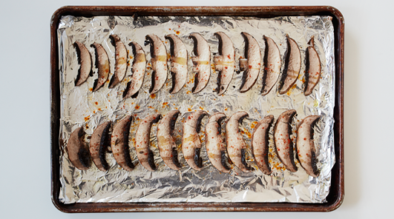

Heat the oven to 400°F. Line a rimmed baking sheet with foil and smear it with 1 tablespoon of vegetable oil. Rinse and dry the portabello mushroom. Slice the cap crosswise as thinly as you can manage; transfer them to the prepared pan, spreading them out into a single layer. Sprinkle with the paprika, salt, and pepper. Transfer the pan to the oven and roast, undisturbed, until the mushrooms release their water and the pan is almost dry again, 20 to 30 minutes.

2.

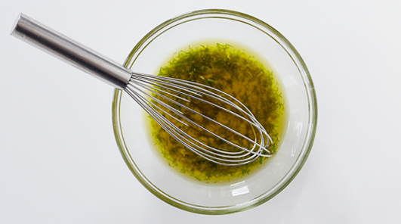

Rinse, dry, trim, and chop the dill. Put the vegan mayonnaise, olive oil, vinegar, mustard, and 1 tablespoon of the dill into a small bowl (save the rest for another use). Sprinkle with salt and pepper and whisk to combine. Rinse and dry the lettuce and tear it into bite sized pieces. Rinse, dry and slice the radishes. Refrigerate the dressing and salad ingredients while you make the cakes.

3.

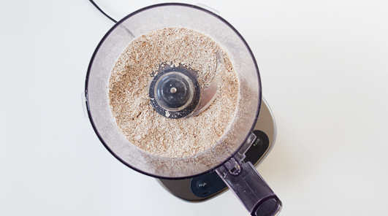

Rinse and dry the button mushrooms. Put the oats in a food processor and let the machine run until they’re ground to a coarse meal, about 1 minute. transfer them to a large bowl. Pulse the garlic in the food processor (no need to wash it first) until the cloves are broken up a bit, then add the button mushrooms. Pulse until the mixture is finely chopped but not pureed. Add the mushrooms and garlic to the bowl with the oats.

4.

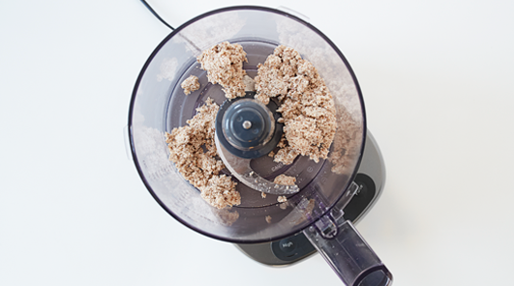

Put the nuts in the food processor (again, no need to wash it) and let the machine run until they’re ground to a thick paste, adding water a teaspoon at a time if necessary just to let the machine do its job; be careful not to make the mixture too wet. Scrape the nut butter into the bowl with a rubber spatula.

5.

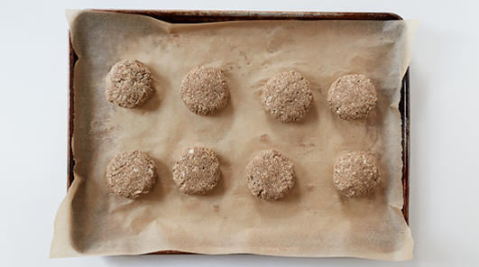

Add the chili powder, a pinch of salt, and pepper to the bowl and stir with the spatula, pressing and folding as you work until the ingredients are distributed evenly. Refrigerate the mixture for 10 minutes, then make 4 cakes, approximately 1/3 cup of the mixture each.

6.

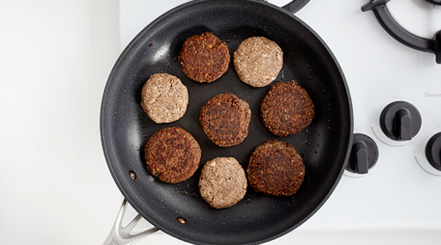

Put the remaining tablespoon vegetable oil in a large non-stick skillet over medium heat. When it’s hot, add the cakes and cook, undisturbed, until they’re browned on the bottom and release easily from the pan, 3 to 5 minutes. Turn the cakes, lower the heat a bit, and cook on the other side until firm and browned, 3 to 5 minutes more. To serve, assemble the salad on large plates, top with the mushroom-nut cakes, crumble the bacon over the top and drizzle the dressing over all.